Dockerizing the Spring boot application:

Step1: Download and install docker on local machine follow instructions given on

For Windows 10: <https://docs.docker.com/v17.09/docker-for-windows/install/#download-docker-for-windows>

For Previous Versions : <https://docs.docker.com/v17.03/toolbox/toolbox_install_windows/>

Step 2: Build a spring boot application db-service

Step 3: Create docker file for db-service as per shown below

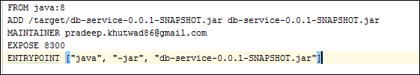

and run command **docker build -t db-service -f db-service .**

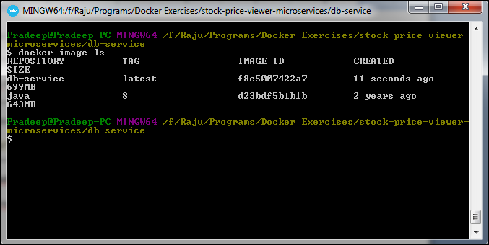

Step 4: pull image of mysql using command **docker pull mysql**

Step 5: Goto Terminal again and run **docker image ls** command to check list of docker images present

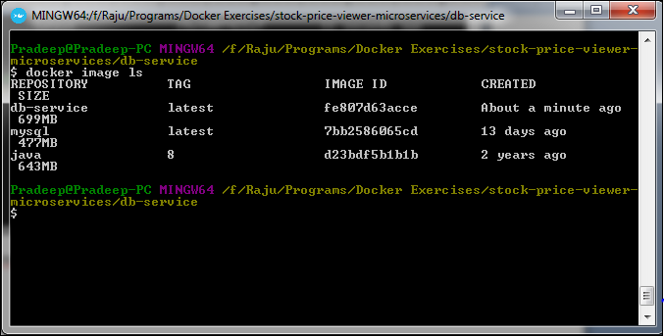  
Step 6: Run docker ps to check running containers

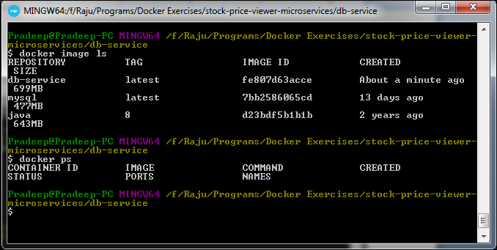

Step 7: to run mysql image use below command

**docker run --name mysql-standalone -e MYSQL_ROOT_PASSWORD=password -e MYSQL_DATABASE=test -e MYSQL_USER=sa -e MYSQL_PASSWORD=password -d mysql**

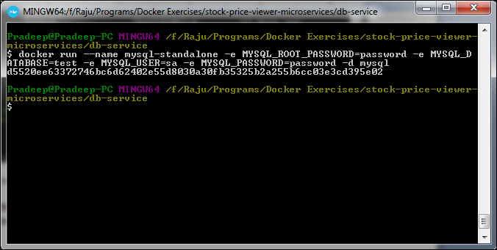

use command to get sql container ip address: **docker inspect <container id> | grep "IPAddress"**

Step 8: To run the created docker image

docker run -it<for interactive mode> -p<ports> <container port mapped with application port>:<application host port> <imagename/imageID>

Use command **docker run -it -p 9999:8300 db-service**

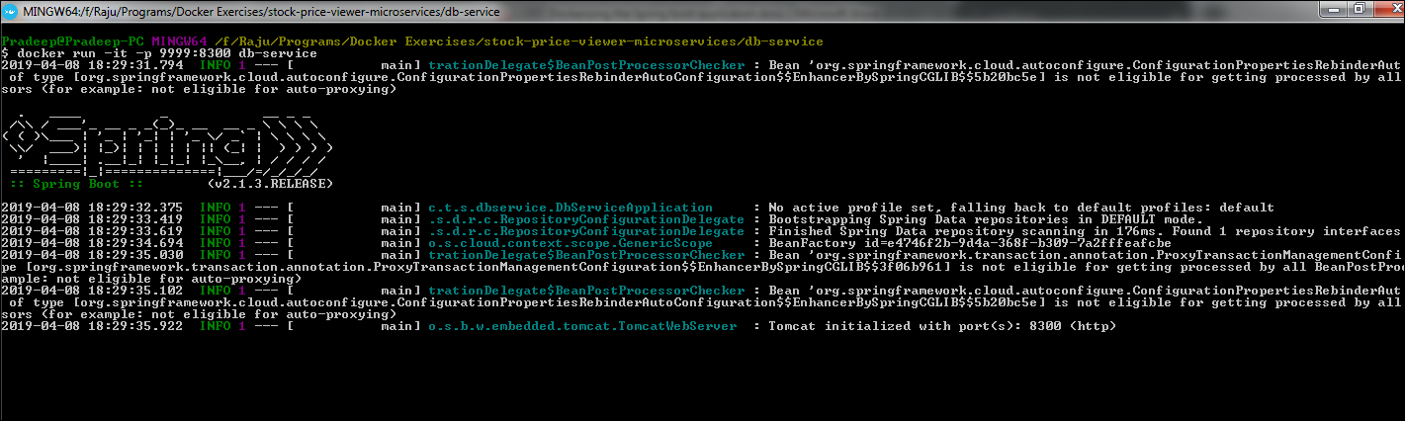

Step 9:

In order to delete all images, use the given command

**docker rmi $(docker images -q)**

In order to delete all containers, use the given command

**docker rm $(docker ps -a -q)**